Little Words currently has a process where they use a customization to generate packages on the fulfillments for Target and then print a custom package label.

There is a button at the top of the item fulfillment form.

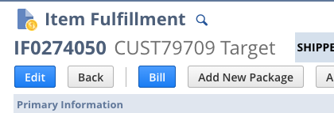

When you click the Add New Package button it launches this URL and form:

<https://5637369.app.netsuite.com/app/common/custom/custrecordentry.nl?rectype=584&compid=5637369&pf=CUSTRECORD_SPS_PACK_ASN&pr=-30&pi=3037182>

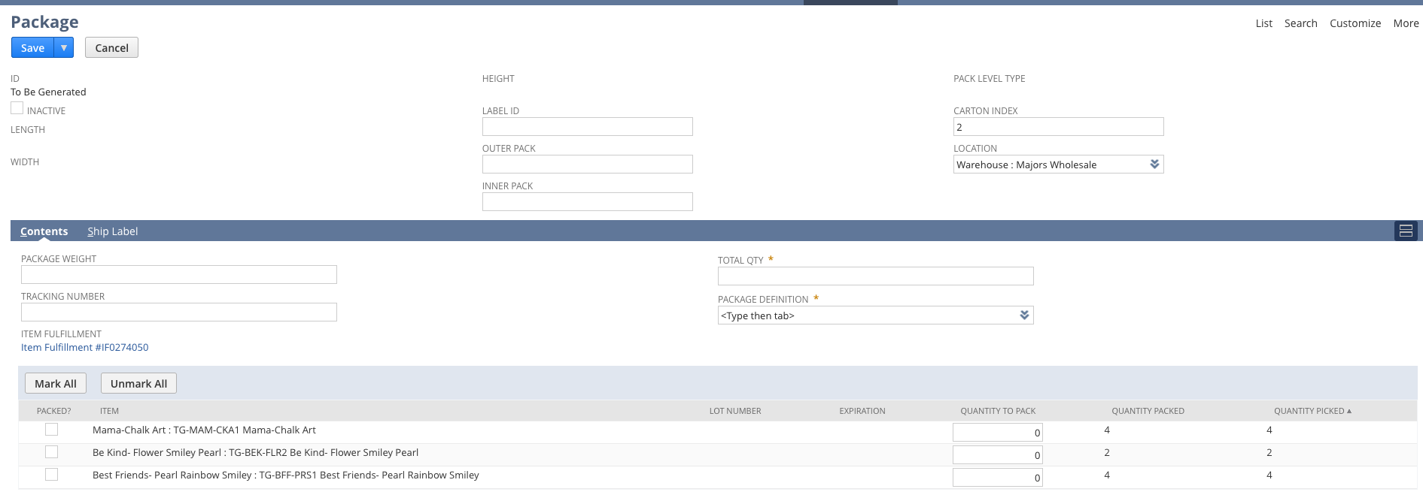

There is also a custom package record used specifically for Target fulfillments.

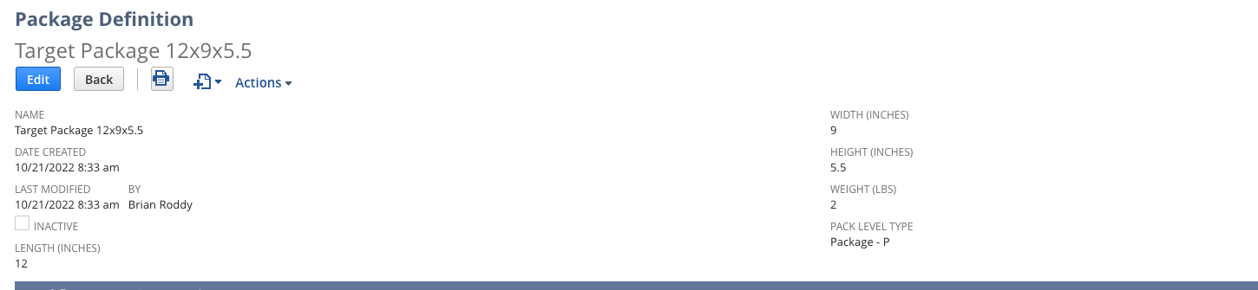

When they create the package the top section of the Package form is empty except for the warehouse value from the item fulfillment and the carton Index value of 1.

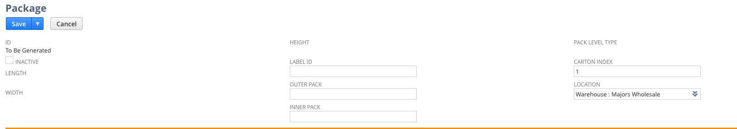

The bottom half of the form lists the line items and qty’s from that item fulfillment.

There are Mark All and UnMark All buttons to select the lines they want to put in the package.

Initially the Total Qty field is set to 0.

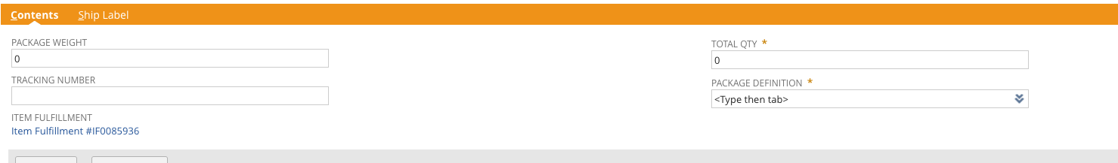

But when you select the lines it adds up the qty’s for the lines they selected.

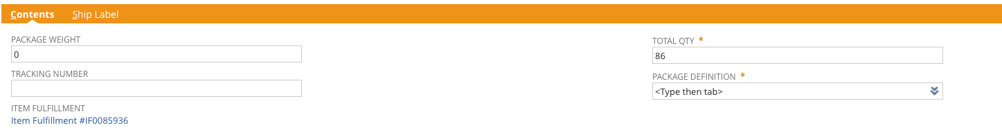

The Package Definition will ALWAYS be the Target Package 12x9x5.5 which is shown at the top of this document.

When they select the package, the Package Weight field populates based on ‘weight’ value set on the Package Definition setup.

When they save the Package it creates a unique package ID value and populates the Package Level Type with Package - P



They also have a Batch Print Labels button on the item fulfillment. When they click this, NetSuite will generate a custom label for each package on the item fulfillment (note: all Target fulfillments will only ever have 1 package ID regardless of the qty).



There is also a link on the package ID under the SPS EDI Packages sub-tab to print labels.

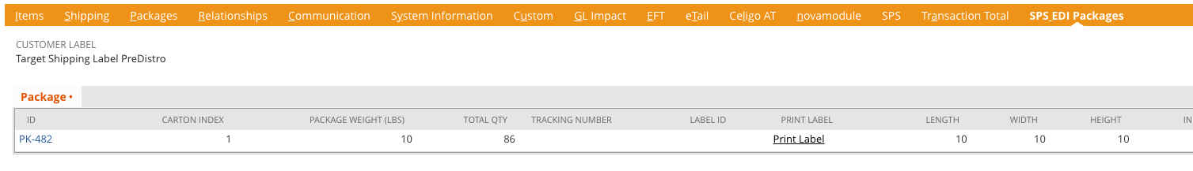

This allows them to also print a label for that package ID.

What we are looking to do is to create a Suitelet similar to what we did for Telfar. We want to have the top section of the Suitelet form have search criteria, such as Customer (to start. We will update with other criteria).

Once they enter the search criteria, the results will be Item Fulfillments for that customer that are in a Picked status that do NOT already have a package ID assigned.

The Suitelet will have Mark All and Unmark All buttons and each result will have a checkbox to select.

When the make the selections of the item fulfillments returns in the search there will be a Submit button.

When they click the Submit button, we need each fulfillment that was selected to have the unique package ID created (as detailed above) and then generate the labels (as detailed above).